Amazon E-commerce Capstone Project

Abstract
This capstone project presents a comprehensive data analysis and predictive modeling framework developed using real-world e-commerce data from Amazon. Our goal was to uncover the interplay between product pricing, discounting strategies, customer reviews, and sales performance. We utilized data preprocessing, machine learning algorithms (specifically Random Forest Regression), and natural language processing (NLP) for sentiment analysis. The final deliverables include predictive models, sentiment-enhanced datasets, and interactive dashboards built in Tableau and Python. These outputs empower decision-makers with actionable insights and data-driven recommendations to optimize pricing strategies, enhance customer experience, and boost sales.

Introduction
Amazon’s platform hosts millions of products spanning diverse categories, ratings, and pricing schemes. Sellers often rely on intuition or historical trends to make decisions about pricing and promotional strategies, which may not always reflect the dynamic and competitive nature of the marketplace. Data analytics offers a structured approach to evaluate these factors in context.
This project focuses on identifying patterns and relationships across three major dimensions:
- Product Pricing & Discounts: How are prices and discounts structured, and how do they impact consumer purchasing behavior?
- Customer Feedback and Sentiment: How does the language in customer reviews reflect on product performance?
- Sales Forecasting Using Machine Learning: Can we predict future product sales accurately and interpretably?
The findings and visualizations produced in this study provide deep insights into pricing optimization, customer preferences, and e-commerce performance forecasting.

Problem Statement
The project seeks to resolve the following business and analytical questions:
- What product attributes contribute most significantly to sales performance?
- How effectively can we predict product sales using machine learning models?
- Can customer sentiment, derived from textual reviews, be quantified and used as a predictive feature?
- How can dashboards be used to translate raw data into intuitive, business-friendly insights?

Proposed Methodology

1. Data Collection & Understanding
- The dataset was sourced from Kaggle’s Amazon E-commerce dataset, including attributes like product_name, category, actual_price, discounted_price, ratings, reviews, and review count.

2. Data Preprocessing
- Removed currency symbols, non-numeric characters.
- Handled missing values using mode/mean for numerical and most frequent values for categorical data.
- Created new features:
  - Discount Percentage = (actual_price - discounted_price) / actual_price
  - Review Sentiment Score using TextBlob
  - Sentiment Label: Positive, Neutral, or Negative based on polarity thresholds

3. Exploratory Data Analysis (EDA)
- Analyzed price distributions, discount impact, rating dispersion.
- Used histograms, box plots, and correlation heatmaps in Python to explore relationships.

4. Sentiment Analysis
- Utilized TextBlob for calculating sentiment polarity from textual reviews.
- Added a new feature: review_sentiment (continuous) and sentiment_label (categorical).
- Verified the distribution across classes: Positive, Neutral, Negative.
- Exported results for use in Tableau visualizations.

5. Predictive Modeling
- Model used: Random Forest Regressor
- Target Variable: Total sales (predicted from price, sentiment, ratings, etc.)
- Features Used: Discount %, Ratings, Category, Review Count, Sentiment Score
- Hyperparameter Tuning: GridSearchCV (n_estimators, max_depth, min_samples_split)
- Validation: 5-fold cross-validation
- Evaluation Metrics:
  - RMSE (Root Mean Square Error)
  - R² Score (Coefficient of determination)

6. Visualization
- Used Matplotlib, Seaborn in Python for model insight plots
- Created a Tableau dashboard for end-user exploration:
  - Interactivity: slicers, filters, hover-tooltips
  - Visual storytelling with KPI indicators and drill-down plots

7. Data Export for Tableau
- Final processed dataset exported as amazon_final_export.csv
- Includes model predictions, sentiment scores, discount percentages, and categorized features

Analysis and Results

Model Evaluation
Metric | Value
RMSE | 27,127,726.54
R² Score | 0.991
A high R² score and reasonably low RMSE confirm that the model captures nearly all variability in the data, making it highly effective for predictive tasks in this context.

Feature Importance from Random Forest
Rank | Feature | Interpretation
1 | Discount Percentage | Products with greater discounts correlate with higher sales volume
2 | Review Sentiment Score | Positive sentiment leads to increased purchases
3 | Rating | Ratings validate customer experience, influencing conversions
4 | Product Category | Some categories inherently drive more volume (e.g., electronics)
5 | Review Count | More reviews suggest popularity and trust, impacting purchasing decisions

Python-Based Visualizations

1. Top Features Influencing Sales
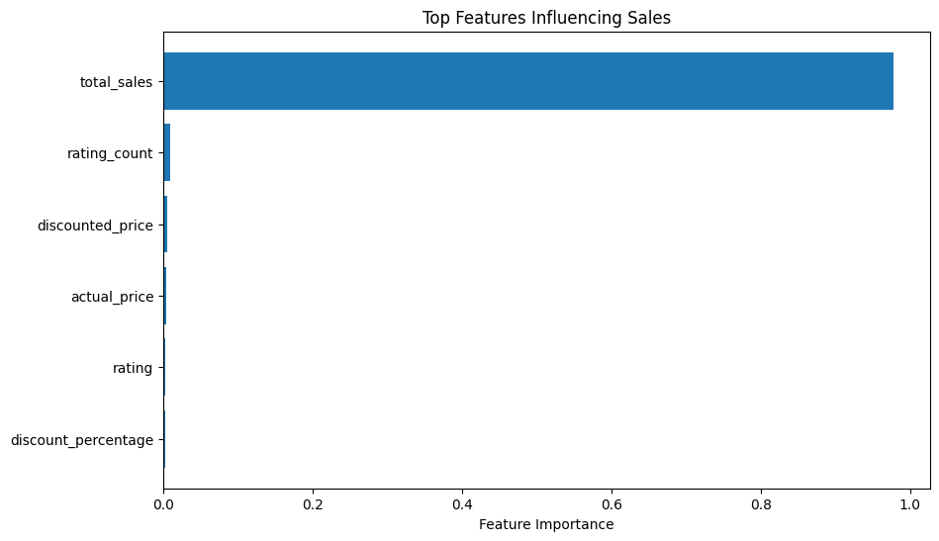

- Description: This bar chart shows the relative importance of various features in influencing sales. The features are ranked by their impact, with total_sales being the most influential, followed by rating_count, discounted_price, actual_price, rating, and discount_percentage.
- Observations:
  - total_sales and rating_count are the top two features, suggesting that products with higher historical sales and more ratings tend to perform better.
  - Pricing-related features (discounted_price, actual_price) also play a significant role, while discount_percentage has the least impact.

2. Correlation Matrix
- Description: This matrix displays the correlation coefficients between pairs of features, ranging from -1 (perfect negative correlation) to +1 (perfect positive correlation).
- Observations:
  - discounted_price and actual_price are highly correlated (0.96), indicating that discounted prices are closely tied to the original prices.
  - total_sales shows moderate positive correlations with rating_count (0.48) and discounted_price (0.46), implying that products with more ratings and lower prices tend to sell more.
  - discount_percentage has weak or negligible correlations with other features, reinforcing its minimal influence from the first visualisation.
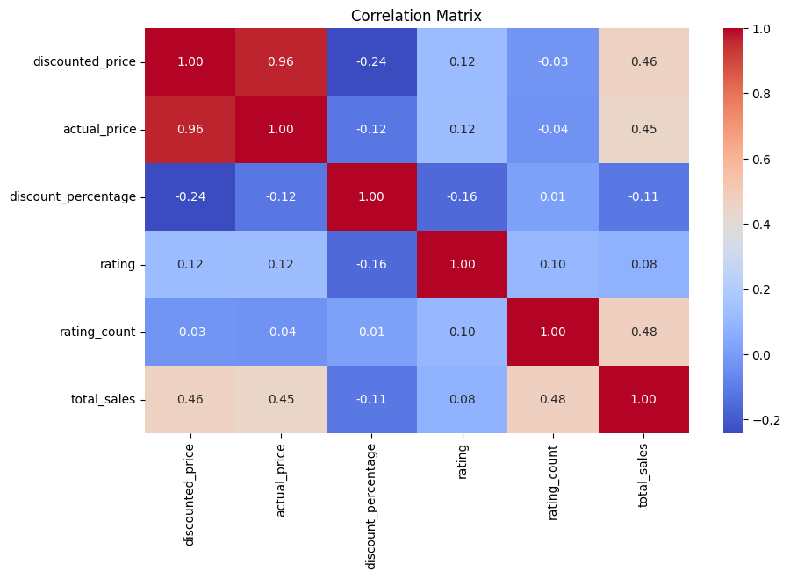

3. Top 10 Product Categories
- Description: This bar chart highlights the top 10 product categories by the number of products. The categories are truncated, but examples include "Computers & Accessories," "Smartphones," and "Smart Televisions."
- Observations:
  - Electronics dominate the top categories, particularly accessories, smartphones, and wearables.
  - The high number of products in these categories suggests they are either highly popular or highly competitive.
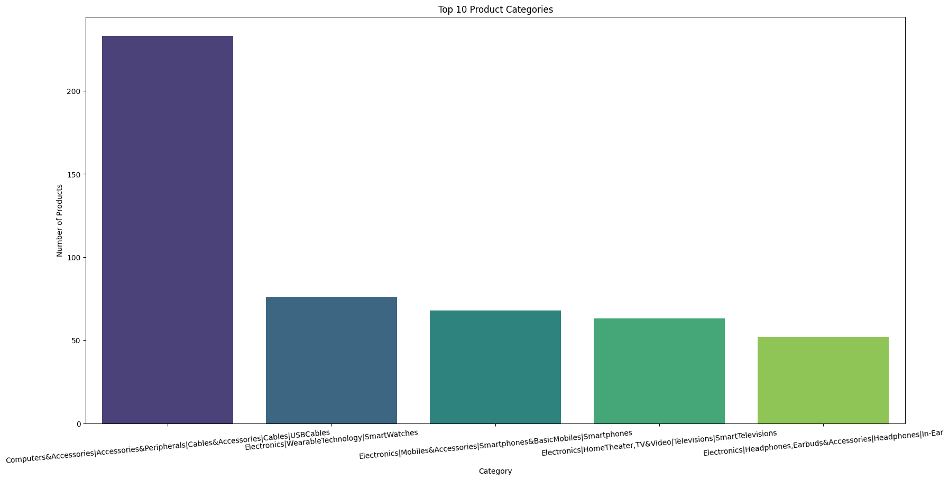

4. Random Forest Feature Importance
- Description: Similar to the first visualisation, this chart ranks features by their importance in a Random Forest model. The order slightly differs, with total_sales and rating_count still leading, followed by rating, discount_percentage, actual_price, and discounted_price.
- Observations:
  - The Random Forest model confirms the importance of total_sales and rating_count.
  - rating and discount_percentage appear slightly more important here than in the first visualisation, suggesting model-specific variations.
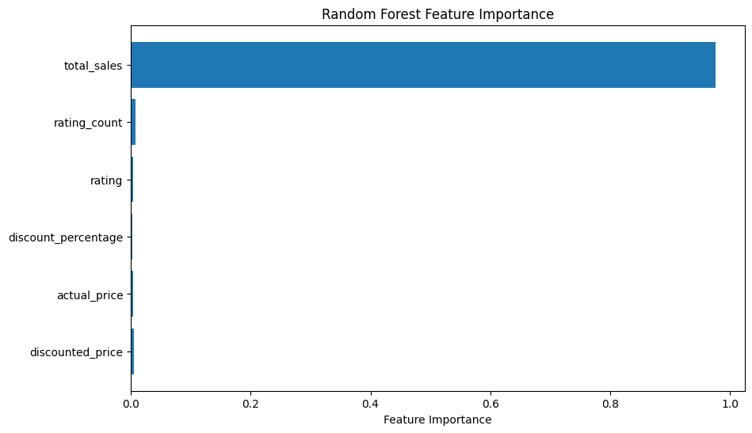

5. SHAP Impact on Model Output
- Description: This plot uses SHAP (SHapley Additive exPlanations) values to show how each feature impacts the model's predictions. Features are ordered by their absolute impact, with total_sales having the highest influence.
- Observations:
  - total_sales and rating_count have the strongest positive impact on sales predictions.
  - discount_percentage has a notable but smaller impact, while actual_price and discounted_price show mixed effects (both positive and negative depending on feature values).
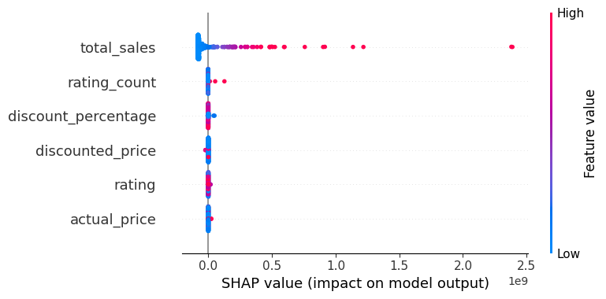

Key Takeaways:
- Sales and Ratings Drive Performance: total_sales and rating_count are consistently the most influential features across all analyses.
- Pricing Matters, but Discounts Less So: While discounted_price and actual_price are important, discount_percentage has limited impact.
- Electronics Dominate Top Categories: The most populated product categories are electronics-related, indicating high demand or competition.
- Model Consistency: Both feature importance and SHAP analyses agree on the top features, reinforcing their reliability.
These insights suggest strategies like boosting ratings, maintaining competitive pricing, and focusing on high-performing categories could enhance sales performance.
Tableau Dashboard: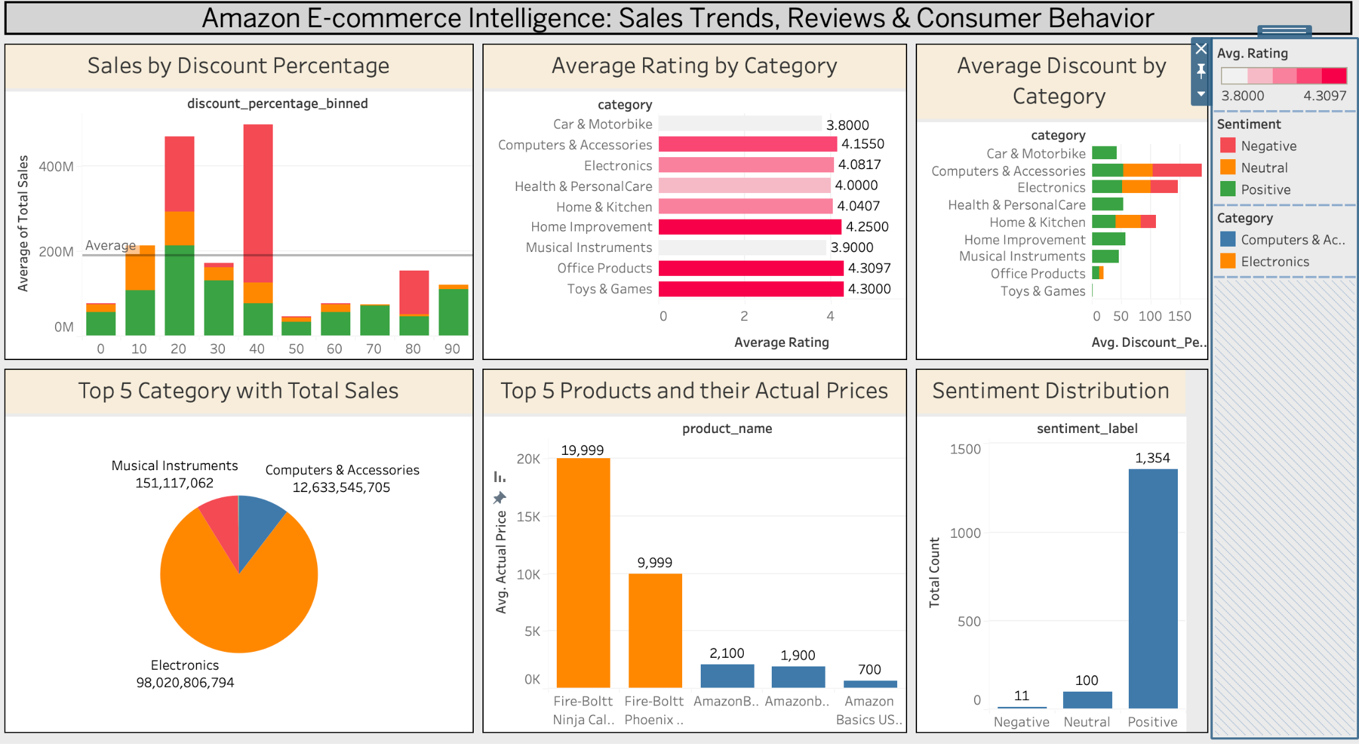

Tableau Dashboard Summary (Based on Final Screenshot)
The Tableau dashboard titled "Amazon E-commerce Intelligence: Sales Trends, Reviews & Consumer Behavior" offers an interactive interface that captures multi-dimensional aspects of product performance across pricing, sentiment, and customer satisfaction. Here’s a detailed breakdown of its insights:

1. Sales by Discount Percentage
- Binned visualization (0% to 90%) showing that sales peak between the 30–40% discount range.
- Positive sentiment (green) dominates this zone, suggesting that customer satisfaction aligns with perceived value.
- Sales decline sharply beyond 50%, indicating possible diminishing returns of excessive discounts.

2. Average Rating by Category
- Visualized using horizontal bars.
- Top-rated categories:
  - Office Products (4.30)
  - Home Improvement (4.25)
  - Computers & Accessories (4.15)
- Lower ratings seen in Car & Motorbike and Musical Instruments, yet these still produce competitive sales.

3. Average Discount by Category
- Displayed as bar chart segmented by sentiment label.
- Categories like Computers & Accessories and Electronics have high average discounts with more positive sentiment, suggesting customers respond well to such pricing in tech-driven categories.

4. Top 5 Categories by Total Sales (Pie Chart)
Category | Total Sales
Computers & Accessories | 12,633,545,705
Electronics | 98,020,806,794
Musical Instruments | 151,117,062
- Electronics and Computers & Accessories contribute over 90% of total sales volume, confirming tech product dominance.

5. Top 5 Products and their Actual Prices
Product | Avg. Price (₹)
Fire-Boltt Ninja Call | 19,999
Fire-Boltt Phoenix | 9,999
AmazonBasics USB | 700
- High-ticket products skew price distributions.
- Yet, affordable items (e.g., AmazonBasics) still maintain high sentiment scores.

6. Sentiment Distribution
Sentiment Label | Count
Positive | 1,354
Neutral | 100
Negative | 11
- Over 90% of product reviews are classified as Positive, which validates the customer-centric design of Amazon’s ecosystem.
- Low negative count shows either strong brand filtering or selective product curation.

Conclusions
Our analysis provided key insights:
- Sentiment is predictive: Beyond being descriptive, it can be used quantitatively.
- Discounting needs balance: Too steep can devalue a product, optimal range is 20-40%.
- Feature engineering matters: Derived features like discount % and sentiment score significantly impacted model performance.
- Data visualization drives storytelling: Tableau dashboards offered decision-makers a powerful lens to engage with the model outcomes.
Business stakeholders can use these insights to:
- Adjust pricing dynamically based on category and sentiment
- Highlight reviews with high positive sentiment to boost conversions
- Use sentiment monitoring as an early indicator for product reputation

Lessons That You Have Learned
This project reinforced several key technical and soft skills:
- Technical Skills:
  - Mastery of data wrangling using pandas
  - Implementing ML pipelines using scikit-learn
  - Sentiment analysis using NLP libraries like TextBlob
  - Dashboarding with Tableau for real-time insights
- Project Management:
  - Weekly planning and milestone tracking
  - Delegation and collaboration using shared tools (GitHub, Google Drive)
- Interpretability vs Accuracy:
  - Trade-offs exist, especially when communicating to non-technical stakeholders
- Visualization for Impact:
  - Tableau provided a bridge between model outputs and executive-level insights
Suggestions to Course Designers:
- Include a dedicated Tableau walkthrough or integration with Jupyter
- Emphasize storytelling with data as much as modeling accuracy

Bibliography
- Amazon Product Dataset on Kaggle
- scikit-learn Documentation (https://scikit-learn.org)
- TextBlob NLP Toolkit (https://textblob.readthedocs.io)
- Tableau Resources (https://public.tableau.com)
- Python pandas, seaborn, matplotlib libraries

Appendix
- Jupyter Notebook: Amazon_E_commerce_Project_Code.ipynb
- Cleaned Data: amazon_final_export.csv
- Tableau Dashboard File: visualisation.twbx
- Output Visualizations:
  - Feature Importance Graphs
  - Sales Scatter Plots
  - Sentiment Polarity Histograms
  - Category-based Performance Plots
- Additional Python Visuals (rating dist., category cross tabs, etc.)

